SCRS/2024/104

**Developing the climate test: robustness trials for climate-ready managemenT procedures**

T. R. Carruthers[1]

*SUMMARY*

The research on climate change impacts on pelagic fish species was reviewed and organized into the theoretical linkages between climatological processes, oceanographic properties affecting habitat, mechanisms of impact and relevant operating model dynamics. The most cited impacts on species biology, ecology and behaviour related to spatial distribution, larval survival, range contraction, adult survival and condition factor. Since few quantitative predictions of climate impacts have been made with regard to these aspects, expert judgement was used to specify proof-of-concept climate tests that included moderate and extreme cases of declining somatic growth, condition factor, adult survival and mean recruitment strength. A range of management procedure (MP) archetypes were tested for their robustness to the climate scenarios including empirical index-target and index-ratio MPs, and model-based stock assessment MPs with and without harvest control rules. MPs that specified effort controls or size limits provided more robust conservation performance for climate tests than their equivalents providing catch advice. Stock assessment model MPs providing catch advice were substantially more robust to declining survival and recruitment when also incorporating a harvest control rule. In general, the most challenging climate tests involved declining survival and recruitment with these leading to larger impacts on yield outcomes than biomass outcomes.

*KEYWORDS*

*Management strategy evaluation, operating model, management procedure.*

**Introduction**

Changing climatic conditions have the potential to substantially alter the abundance, productivity and species composition of pelagic marine ecosystems (Beaugrand and Kirby 2023, Bell et al. 2011). Climate processes (e.g., thermal regime, concentration of greenhouse gasses) are linked to oceanographic conditions (e.g., ocean temperature, ocean mixing, stratification, pH & salinity) which in turn, affect fundamental ecological processes such as primary productivity, community dynamics and species-specific dynamics such as the location and amount of suitable habitat, species distribution, survival of various life stages, condition factor, fecundity and somatic growth (Walther et al., 2002; Doney et al., 2012; Free et al., 2019). Due to increasing anthropogenic greenhouse gas emissions, climate processes affecting marine ecosystems are forecasted to intensify (Hoehy-Guldberg et al. 2018; Kwiatkowski et al., 2020).

In their review of impacts on large pelagic fish in the Northwest Atlantic, Dell’Apa et al. (2023) provide a useful synthesis:

“Additionally, the Northwest Atlantic Ocean has been characterized by several climate-driven changes in regional environmental conditions over recent decades, including warmer sea surface temperature (SST) (Karnauskas et al., 2013; Loder and Wang, 2015) and bottom water temperature (Brickman et al., 2018), increased summertime stratification of shelf waters (Li et al., 2015), changes in dissolved oxygen concentration (DO) levels (Stendardo and Gruber, 2012) and acidification (Cai et al., 2011), and altered oceanographic processes (Karnauskas et al., 2015)”.

Establishing climate-ready management is a key priority for many regional fishery management organizations in light of persistent declines in various species (Pacoureau et al. 2021) and concern that fishing may increase the sensitivity of marine populations to climate change (Hsieh et al. 2008).

Evaluating the climate-readiness of current and alternative management options requires models that can predict fishery and population dynamics. Unfortunately, forecasting the impacts of climate changes on managed pelagic species is highly uncertain. In theory, it is possible to combine models of emissions (e.g., Algieri et al. 2023, Wang et al. 2017), earth systems (Kawamiya et al. 2020), ecosystems (e.g., Beaugrand and Kirby 2018, Lehodey et al. 2010; 2011), behaviour (e.g., Bushnell and Brill 1991, Cayré and Marsac 1993) and physiology (e.g., Gooding et al. 1981, Graham et al. 1989, Essington 2003, Checkley et al. 2009). In doing so, forecasting combines a complex series of linked projections that include greenhouse gas emissions (least uncertain), response of climate processes (uncertain), linkages with oceanographic conditions (more uncertain) and the expected impact of those on pelagic communities and individual species (most uncertain). It follows that any climate change scenario for establishing climate-ready management advice for a given fish stock is firmly hypothetical, and the relative credibility of scenarios should be considered highly uncertain.

While it may be extremely difficult to establish a scientifically defensible ‘base case’ or ‘most credible’ climate impact scenario for evaluating management advice for a given species and fishery, there are methodological frameworks that are designed expressly to account for uncertain hypothetical states of nature. Management strategy evaluation (MSE) is a participatory process to establish fishery management procedures (MPs, harvest strategies – algorithms for calculating management advice from data) that are robust to uncertainties in fishery and population dynamics (Punt et al. 2016).

MSE involves the specification of operating models that represent plausible states of nature that span uncertainties. These operating models are typically divided into a reference and robustness sets. Reference set operating models include primary uncertainties that may be supported by empirical evidence. Robustness operating models (robustness trial / robustness test) include secondary uncertainties that are often hypothetical or relatively uncertain. The reference set are the primary basis for the comparative evaluation of candidate MPs. The robustness set are used to further discriminate among candidate MPs that perform similarly for the reference set. Robustness operating models also provide a basis for evaluating whether hypothetical states of nature are consequential to management outcomes. For this reason, MSE provides a framework for developing and implementing tactical advice that is robust to hypothetical climate scenarios. If an MP performs similarly for the reference set of operating models, there is no coherent reason not to select the MP if its climate performance is superior (Figure 1). There has been increasing interest in MSE as a practical path forward for establishing MPs that are robust to potential climate impacts (e.g., Free et al. 2023, Collie et al. 2021)

Establishing a standard set of climate change robustness tests would potentially allow for the design of climate-ready candidate MPs and the adoption of an MP for which climate-change robustness has been demonstrated rigorously. In the paradigm of MSE the emphasis would not be on establishing ‘most credible’ climate impact forecasts for individual species, but rather on establishing MPs that are robust to a wide range of possible climate scenarios, acknowledging that there is a high degree of uncertainty in forecasting climate impacts. The motivation: a cost-effective and pragmatic approach to making progress in identifying climate-ready management practices.

This paper reviews the research on climate change impacts on pelagic fish species and links these to operating model dynamics for multiple of species of highly migratory tunas, sharks and billfish to test the robustness of various MPs. This iteration of the climate test is intended to be a proof-of-concept, necessarily focusing on very broad, generic robustness tests for the purpose of gathering feedback to improve and refine the framework. A key aim in the development of the climate test is to include a larger quantity of information about possible climate impacts allowing for bespoke robustness testing specific to taxon and location.

**Methods**

***Scoping climate scenarios***

The literature on climate change and its impacts on marine ecosystems, specific populations and fisheries is broad and extensive covering the various components that link projections of emissions to possible impacts on the ecology, behaviour and biology of highly migratory species (Figure 2) (see Poloczanska et al. 2016 for an overview). The current research on climate change impacts on pelagic fish species was reviewed and organized into the theoretical linkages between climatological processes, oceanographic properties affecting habitat, mechanisms of impact, and the relevant operating model dynamics (Tables 1-3).

In general, a much larger number of mechanisms for impacts have been described relative to the number of ways in which these can impact operating model dynamics (Figure 2, Table 2). The most frequently cited categories of impact that are considered of highest priority relate to: spatial distribution, larval survival (recruitment strength), range contraction (carrying capacity, mean recruitment), adult survival (natural mortality rate) and condition factor (weight at length). Almost all papers that evaluate impacts on pelagic fishes, do so qualitatively (e.g., Dell’Apa et al. 2018, Lehodey et al. 2011, Poloczanska et al. 2016). A recent ICES technical working group ‘WKecoMSE’ (May 2024) evaluating how environmental variables could be incorporated into MSE frameworks provided a valuable synthesis. The discussions and working papers of that group further confirmed that there is a general lack of empirical studies identifying mechanistic linkages that quantify climate impacts to pelagic fish species (Pörtner and Peck 2010).

Through a mixture of empirical studies, theoretical linkages and expert judgement, Dell’Apa et al. (2023) determined a series of qualitative changes for the major groups of highly migratory species inhabiting the Northwest Atlantic Ocean. They provide a useful table of expected impacts in terms of the qualitative direction of impact, such as declines in somatic growth and survival of larval stages. Along with work conducted on tropical tunas in the Pacific (Lehodey et al. 2011), these studies were used to produce proof-of-concept climate tests that included four key operating model properties:

1. recruitment strength;
2. adult survival;
3. somatic growth rate;
4. condition factor.

Table 3 provides a summary of the mechanisms relating to each of operating model property. Recruitment strength is intended to simulate changes in survival of early life stages and shifts in carrying capacity (e.g. range contraction). Adult survival addresses changes in food availability, physiological stress, post-release mortality and costs of behavioural adaptations such as increased foraging time. Somatic growth rate and condition factor are intended to simulate reduced food availability, increased foraging time, competition for food and physiological stress due to, for example, reduced oxygen concentrations and warmer ocean temperatures. As a demonstration, both moderate and extreme values of each impact were simulated using quantities that were derived entirely from this author’s expert judgement (are not empirically derived or scientifically defensible).

In their review of the Marine Climate Change Impacts Database (MCID) Poloczanska et al. (2013, 2016) found that changes in spatial distribution and phenology were the most frequently reported category of impact. Spatial distribution is however one of the hardest robustness tests to implement since it is highly context specific. For some species, overall distributional shifts to higher latitudes have been observed (Perry et al. 2005, Nye et al. 2009, Last et al. 2011). However, for highly migratory species such as tunas, theoretical models predict both range expansion and contractions both towards and away from fishing pressures (e.g., tropical tunas of the Pacific Ocean, Lehodey et al. 2011). In this demonstration paper, spatial distribution was not considered but has implications for operating model properties such as carrying capacity, catchability, somatic growth, condition factor and natural survival.

To understand the sensitivity of management procedures to climate scenarios, a reference run (‘Ref’) was conducted without any changes in the operating model dynamics.

***Reference operating models***

Operating models were developed for the six pelagic species of the EcoTest project (Huynh et al. 2022, Carruthers et al. 2024) that are based on documented stock assessments: Atlantic bigeye, swordfish, blue shark, shortfin mako shark, white marlin, blue marlin (Table 4, Figure 3). The operating models were developed in the openMSE framework (Hordyk et al. 2024). The climate tests were developed to be generic (i.e., are scale-free) and can be applied to any of the 100+ operating models already developed in the openMSE framework. For the purposes of clarity, only the results for bigeye tuna, blue shark and swordfish are presented here.

***Management Procedures***

The climate test scenarios were projected for a set of archetypal MPs that respond to various data (relative abundance indices, catch data, no data – are prescriptions), calculate advice in various ways (aim for a relative abundance index level, aim for a constant exploitation rate, use a stock assessment model and harvest control rule) and provide advice in terms of various management levers (e.g., total allowable catch, total allowable effort, size limits, spatial closures) (see Table 5 for the MPs that were tested). The focus of this MP evaluation is on the type of MP as it is intended to be used. To this end, where applicable, the MPs include observation error in catches and indices of abundance but are omniscient with regard to target levels of the index relative to SSBMSY and effort relative to UMSY, for example. While they are not tuned to performance outcomes, by aiming for MSY levels, the MPs share a common theoretical thread (this is not applicable to the size limit and spatial closure MPs that are not based on MSY quantities).

***Quantifying management performance***

The performance of the MPs was evaluated with respect to biomass and yield outcomes over the long-term in order to better reveal differences in MP properties. Long-term outcomes are less dependent on starting projection conditions and allow for a clearer understanding of asymptotic MP performance. Yield was quantified as catch in year 50 of the projection divided by the catch observed in the last historical year (before the MP was applied). Biomass was quantified as spawning stock biomass (SSB) in projection year 50 relative to equilibrium SSB at FMSY fishing levels (SSBMSY) where SSBMSY was time-invariant and calculated from the relevant parameters in the final historical year of the operating model (not a dynamic reference point accounting for changes in operating model parameters). 128 simulations were used to characterize performance. For each species, projected conditions (process and observation errors) were identical among MPs and climate tests with the exception of the modified aspects of the specific climate tests.

**Results**

***Survival and recruitment the most impactful robustness tests***

When comparing climate tests, the survival (e.g., M_ext) and recruitment scenarios (e.g., Rec_ext) were the most consequential, generally affecting yield outcomes more substantially than biomass outcomes (Figures 4 and 5).

***Robust biomass performance of responsive / compensatory MPs***

The large impact on yields relative to biomass outcomes is indicative of responsive MPs, for example TAC-based MPs such as SP_4010 for bigeye under the extreme survival example (‘M_Ext BET’, panels of Figures 4 and 5). Some MPs may not necessarily be responsive but rather compensate better for declining biomass levels. For example, the size limit at maturity is a constant management prescription that is relatively robust to the declining survival tests in terms of biological performance (Figures, 5, 8, 9).

***Failure of index-based MPs providing catch advice***

The index target and index ratio MPs providing TAC advice (ITC and IRC respectively) often performed the least well in terms of long-term yield and biomass outcomes (i.e., they chronically overfished). This was particularly evident in the bigeye tuna simulations (e.g., Figure 5). When providing effort control the same MPs could provide substantially better performance in terms of both long-term yield and biomass outcomes, for example, the moderate somatic growth (K_Mod), survival (M_Mod) and recruitment (Rec_Mod) tests (Figure 8).

***Climate tests less strongly impacted MP ranking***

While the demonstration climate tests could substantially affect the absolute performance of MPs, particularly in terms of yield, often the relative position of the MPs in the yield-biomass trade-off space was more consistent, (e.g., the MPs maintain relative performance differences for the moderate recruitment test – bottom row of Figure 8).

***The role of harvest control rules***

The stock assessment model that included throttling of exploitation rate when estimated stock declined below 40% of unfished levels (SP_4010) was comparable to the constant FMSY assessment (SP_MSY) for some scenarios, but provided significantly superior biomass performance for the reduced survival tests and reduced recruitment tests (M_Ext and Rec_Ext panels of Figure 5, respectively).

**Discussion**

***The distinction between scientific uncertainty and management uncertainty***

There is increasing recognition that fishery management practices should be robust to plausible changes in the ecology, behaviour and biology of exploited species in response to changing ocean conditions. Over the last 20 years, an extensive body of research has discussed, described and modelled the drivers, mechanisms and possible climate change impacts on marine fish populations. A large number of ways in which climate change could dramatically impact the abundance, distribution and productivity of marine fish populations have been identified. As a backdrop to this research there have been persistent declines in some pelagic fish populations (Pacoureau et al. 2021) correlated with systematic changes in oceanic conditions. Coupled with research suggesting that fishing could increase the sensitivity of marine populations to climate change (Hsieh et al. 2008), there is increasing interest in developing management strategies that are robust to climate driven impacts (Free et al. 2023, Collie et al. 2021, Hollowed et al. 2020).

A principal obstruction to progress has been developing scientifically defensible quantitative projections of impacts on marine populations that could be used for informing management strategies. Scientific uncertainty in quantitative projections is necessarily high and the product of uncertainty in models of emissions, climatology, oceanography, ecology, behaviour, physiology and fishery exploitation. The core question of this research remains open: if scientific uncertainty over climate impacts on fisheries is inevitably very high (may always be very high), should this necessarily obstruct progress in establishing robust fishery management practices? The value of MSE-style simulation, and the reason why it may unlock progress in establishing climate-ready management practices, is that it reveals the important distinction between scientific uncertainty and management uncertainty.

The results of the generic, proof-of-concept climate tests of this paper suggest that it may be possible to identify fishery management archetypes that are likely to respond or innately compensate for some of the most important climate impacts on individual populations such as recruitment, survival and somatic growth. By accounting for feedbacks between the population, data and the management procedure, MSE may provide a more rigorous basis for selecting management options than descriptive tools for risk and vulnerability assessment (e.g., Chin et al. 2010, Hare et al. 2016). The large number of upstream climate-oceanography-habitat mechanisms distil down to a relatively small number of processes within a conventional population dynamics model (a relatively terse set of conceivable tests), even fewer still may be consequential to the selection of MPs. Qualitatively, the direction of the robustness test is known in terms of its challenge for MPs, for example decreasing survival, decreasing somatic growth, increasing catchability, range contraction. It follows that what starts as an overwhelming number of hierarchical and interweaving climate-population mechanisms, may end in a much more concise set of climate tests.

***Management procedure performance***

The MPs that were tested exhibited varying degrees of responsiveness but in general showed a tendency to reduce fishery yields in the conservation of spawning biomass. The most stringent climate tests came in the form of reduction in survival and recruitment strength, which could be particularly problematic for index-based management procedures providing TAC advice. MPs linked to input controls, such size limits and TAE provided greater robustness since these controls provided consistency in exploitation rate; automatically reducing catches as vulnerable biomass declines. It should be noted that the success of the TAE MPs is dependent on the simulated variability and change in catchability which, if set unrealistically low could exaggerate their relative performance benefits. Simple state-space surplus production stock assessment models setting TAC advice (e.g., SP_MSY, SP_4010) provided greater responsiveness than index-based TAC MPs (ITC, IRC). Even though these assessments were essentially mis-specified, their estimation of population dynamics favoured climate-robustness (the scientific veracity of the assessment was not necessarily a determinant of its expected management performance). Incorporating a harvest control rule (SP_4010) provided appreciably superior biomass conservation performance in the declining survival and recruitment scenarios. Depending on which climate tests are considered important, implementation of harvest control rules and their refinement could provide substantial benefits in terms of expected robustness.

***Generic versus bespoke robustness testing***

The research of this paper has been deliberately presented as a proof-of-concept and there are important limitations, the largest of which is the magnitude of the quantitative specification of the moderate and extreme tests. These were derived from the expert judgement of the author based on observed historical changes in population dynamics determined by participation in various stock assessment processes. The extensive body of research into the various ways that climate change could ultimately affect marine organisms provides remarkably limited quantitative understanding of likely impacts. There remains a critical need for empirical verification of theoretical models to have confidence over their predictions (e.g. Poloczanska et al. 2008, Wethey and Woodin 2008).

It is arguable that since forecasting is highly uncertain, the most defensible approach would be a more careful synthesis of case studies where historical trends have occurred; using these as the basis for scoping the approximate magnitude of future impacts (i.e., Murawski 1993, Nye et al. 2014). While absolute changes in projected dynamics (e.g., a 50% decline in survival, a 25% decline in somatic growth) may be highly uncertain, the relative size of these changes may be better characterized and constrain the range of credible climate tests (i.e., survival changes are generally double those relating to somatic growth).

A strong scientific argument can be made against generic simulation testing of the type applied in this paper in which the same relative impacts in the same direction were applied across multiple species. There is a clear scientific argument for location- and species-specific magnitude and direction of impacts. In their synthesis of physiological and behavioral dynamics of tropical tunas in the Pacific, Lehodey et al. (2011) provide an informative review: theoretical models suggest that primary productivity changes that could drive carrying capacity, growth and reproduction are region specific; on an individual species level, the degree to which pelagic fish species can acclimatize to climate impacts is likely to vary strongly depending on their physiology and behavior (e.g., most tuna species have a vascular heat exchanger that allows them to regulate core and muscle temperatures providing them with a broader thermal niche than other pelagic taxon); among tunas, some species appear to have varying degrees of tolerance to reductions in dissolved oxygen.

Although bespoke climate tests specific to taxon and region may be supported by the scientific view, it necessarily demands defensible quantitative specification of scenarios which would take significant resources and delay action in establishing robust management practices in many cases. A possible solution, as presented here, is to start with generic tests and refine these to more bespoke climate tests as informative data, hypotheses and models become available, focusing first on simpler, generic and more demanding tests of robustness (in doing so incentivizing further research to support more bespoke robustness tests).

By incorporating climate tests in an established MSE framework, it is relatively straightforward to apply these to new and existing case studies (such operating models are already available for ICCAT stocks such as Western skipjack tuna, the eastern tropical tunas, North Atlantic swordfish and South Atlantic swordfish). For example, it is a single command to convert most stock assessment models to an OpenMSE operating model, another command to modify that operating model for a climate test projection, a third to do the projection and plot results. Since a range of documented management procedures are already available in OpenMSE including data rich and data poor stock assessments, empirical MPs, size limits and spatial controls, it is straightforward to identify management procedure archetypes that are likely to be climate-ready.

***Systematic shifts and variability in dynamics***

Another important limitation of this demonstration analysis is the simulation of only persistent, systematic changes (e.g., shifts in the mean levels of quantities such as natural mortality rate and recruitment). Much of the research on impacts suggests that there could be increasing variability, step changes or regimes shifts (i.e., Parsons and Lear 2001, Poloczanska et al. 2013, 2016). Similarly to the scoping of systematic changes, known historical variations from established cyclical environmental processes (e.g., Atlantic multidecadal oscillation, Pacific El-Nino southern oscillation and decadal oscillation) could be used to scope the approximate magnitude and relative magnitude among impacts. For example, Lehodey et al. 2011 cite the example of apparent skipjack tuna recruitment pulse following the strong ENSO events of 1997–1998, thought to the product of an unusually large phytoplankton bloom:

“Evidently, the bloom of phytoplankton and subsequent production of zooplankton led to an increase in survival rates of larval and juvenile skipjack tuna. These fish produced a strong cohort that recruited to the fishery 6–12 months later”.

***Climate-appropriate reference points***

Biomass performance outcomes were evaluated according to equilibrium spawning stock biomass at MSY fishing levels. This is a constant theoretical value determined by fishery selectivity, natural mortality, maturity, growth and condition factor at start of the projection. By using a constant yardstick, it is hard to compare the performance of MPs across climate tests because some tests necessarily incur a declining unfished reference level. Additionally, any additional variance introduced by robustness tests can serve to obscure the expected difference in performance outcomes among MPs. An argument can be made for dynamic biomass reference points that automatically set a higher bar for management performance when stock levels naturally increase and a lower bar when stock levels naturally decline. On the one hand, it can be argued that changes in productivity and carrying capacity are among the most important characteristics that differ spatially among discrete fish stocks: it would be considered generally inappropriate to take the values from a stock in the Pacific and assume these for the same species in the Atlantic, for example. On the other hand, if the differences over time due to climate impacts within a stock are of comparable magnitude to that among stocks, then it stands to reason that management should be evaluated according to the new reality rather than an outdated and non-applicable equilibrium level (that could be higher and punitive, or lower and permissive). From a climate robustness testing perspective, dynamic reference points are attractive, however arguments against their use are important and based on problematic dynamical properties of populations that have been observed at low levels such as Allee effects that can drive chronic depensation. Rather than establishing climate ready MPs, there has been work that focuses on the evaluation of stock status and management performance using appropriate reference points; referred to as ‘climate aware’ by Punt et al. (2024).

***Climate test outcomes***

When testing an MP for climate robustness, three discrete outcomes can be envisaged that depend on the frequency with which the MP fails to meet management objectives given the climate test robustness scenarios (‘failure rate’):

|  |  |
| --- | --- |
| (**robust**) | Failure rate of the MP is acceptably low; |
| (**conditional**) | Failure rate of the MP is higher than acceptable but conditions where the MP fails are detectable given available data; |
| (**not robust**) | Failure rate of the MP is higher than acceptable and conditions where the MP fails are not detectable given available data. |

Clearly the *robust* outcome is the most desirable and least problematic, allowing for the use of an MP with demonstrated robustness to the applicable climate tests. The *conditional* outcome allows for the use of the MP but requires the collection of data that provide a sufficiently informative indicator of conditions where the MP is vulnerable to climate test scenarios. This is analogous to the MSE concept of ‘exceptional circumstances’ where, if meaningful departures in operating model dynamics are detected this may lead to a review of the operating models and potentially the MP (Punt et al. 2016). Carruthers and Hordyk (2018) demonstrated that fishery data streams can provide relatively high statistical power to detect important shifts in parameters controlling productivity, carrying capacity, growth and catchability, indicating that the *conditional* outcome is potentially viable and could still allow for implementation of climate-ready management options. The *not robust* outcome is the most problematic: climate scenarios strongly affect MP performance and these scenarios are not detectable. This outcome places additional value of information on likely climate impacts in order to better refine projections and select a robust MP.

***Asymmetry in performance outcomes***

When comparing the performance of MPs it is not appropriate to report results for only the hypothetical climate test operating models. The design of MSE generally prevents this as reference case (no climate impacts) and robustness tests (e.g., climate tests) are generally considered across MPs. However, often ‘ecosystem-ready’ and ‘climate-ready’ MPs are first presented in working groups only showing their benefits for the climate scenarios they were expressly designed for (i.e., the shaded cells of Table 6) sometimes circularly, modifying advice using indicators that are directly linked to the simulated climate impacts (a form of simulated omniscience).

There may be a significant asymmetry in performance outcomes for the reference set operating models and those for the climate test operating models. Table 6 provides an illustrative example where the current management approach (‘Current MP’) is compared with a new MP designed for robustness to climate test conditions (‘Climate MP’). In example *A* the Climate MP performs comparably to the Current MP for the reference set operating models but provides a marked improvement in performance under climate conditions. However, in example *B*, the climate MP is substantially worse for the reference set operating models and only incrementally better performing than the current MP for the climate test scenarios. It is important that any such asymmetry is conveyed to managers when considering MPs designed to address particular operating model conditions.

***Other limitations***

The robustness tests of this paper only simulated negative impacts but some stocks may be climate ‘winners’ (Fulton 2011). It is important to recognize these cases since more conservative MPs for climate sensitive species could be perceived as acceptable when considered alongside more aggressive MPs designed for species whose productivity and abundance are positively impacted.

A substantial body of research details changes in genotype in response to climate pressures (Chown et al. 2010, Chevin et al. 2013, O’Brien et al. 2013, Banks et al. 2010, Crozier and Hutchings 2014) and these factors were not simulated in these analyses but imply systematic changes and would support use of dynamic reference points in performance evaluation.

***Other improvements***

It may not be appropriate to simulate single one-factor departures in operating model dynamics. Most qualitative hypotheses for the mechanisms of impact on populations suggest that changes in growth, condition factor, survival, fecundity and recruitment can be expected to co-vary (Neuheimer et al. 2011), in doing so reducing the number of credible climate test scenarios.

Future versions of the climate test should better simulate survival that varies between life stages (larval, juvenile, adult) given their varying exposure and tolerance to climate effects (Rijnsdorp et al. 2009, Lehodey et al. 2011).

Further development of the climate test should continue to build a supporting data base of quantified forecasted climate impacts for specific species and locations to provide increasingly bespoke robustness testing of climate scenarios for pelagic fish species.

**Code and data**

All code, models and data used in these analyses are available from the public Climate Test GitHub repository: https://github.com/Blue-Matter/ClimateTest

**Acknowledgments**

This research was funded by The Ocean Foundation. Many thanks to John Walter, Adrian Hordyk, Quang Huynh, Shana Miller and Grantly Galland for their helpful comments on this work.

**References**

Anonymous. 2017. REPORT OF THE 2017 ICCAT SHORTFIN MAKO ASSESSMENT MEETING. SCRS/2017/007 Collect. Vol. Sci. Pap. ICCAT, 74(4): 1465-1561.

Anonymous. 2018. REPORT OF THE 2018 ICCAT BLUE MARLIN STOCK ASSESSMENT MEETING. SCRS/2018/008. Collect. Vol. Sci. Pap. ICCAT, 75(5): 813-888.

Anonymous. 2020. REPORT OF THE 2019 ICCAT WHITE MARLIN STOCK ASSESSMENT MEETING. SCRS/2019/009. Collect. Vol. Sci. Pap. ICCAT, 76(4): 97-181.

Anonymous. 2021. REPORT OF THE 2021 BIGEYE STOCK ASSESSMENT MEETING. SCRS/2021/011. Collect. Vol. Sci. Pap. ICCAT, 78(2): 335-485.

Algieri, B., Iania, L, Leccadito, A. 2023. Looking ahead: forecasting total energy carbon dioxide emissions. Cleaner Environmental Systems. 9. https://doi.org/10.1016/j.cesys.2023.100112

Atkinson D. 1994. Temperature and organism size—a biological law for ectotherms? Adv. Ecol. Res. 3:1–58

Banks, S. C., Ling, S. D., Johnson, C. R., Piggott, M. P., Williamson, J. E., and Beheregaray, L. B. 2010. Genetic structure of a recent climate change-driven range extension. Mol. Ecol. 19, 2011–2024. doi: 10.1111/j.1365-294X.2010.04627.x

Bell, J.D., Johnson, J.E., Hobday, A.J. 2011. Vulnerability of Tropical Pacific Fisheries and Aquaculture to Climate Change. Secretariat of the Pacific Community, Noumea, New Caledonia.

Beaugrand, G. 2009. Decadal changes in climate and ecosystems in the North Atlantic Ocean and adjacent seas. Deep Sea Res. II Top. Stud. Oceanogr. 56, 656–673. doi: 10.1016/j.dsr2.2008.12.022

Beaugrand, G., Brander, K.M., Lindley, A.J., Souissi, S., Reid, P. C. 2003. Plankton effect on cod recruitment in the North Sea. Nature Letters. 426: 661 – 664.

Beaugrand, G., and Kirby, R. R. 2010. Spatial changes in the sensitivity of Atlantic cod to climate-driven effects in the plankton. Clim. Res. 41, 15–19. doi: 10.3354/cr00838

Beaugrand, G., Kirby, R.R. 2023. How do Marine Pelagic Species Respond to Climate Change? Theories and Observations. Annual Review of Marine Science. 2018 (10): 169-97. https://doi.org/10.1146/annurev-marine-121916063304

Bigg GR. 1996. The Oceans and Climate. Cambridge, UK: Cambridge Univ. Press

Brickman, D., Hebert, D., and Wang, Z. 2018. Mechanism for the recent ocean warming events on the Scotian Shelf of eastern Canada. Cont. Shelf Res. 156, 11–22. doi:10.1016/j.csr.2018.01.001

Bushnell, P. G., and Brill, R.W. 1991 Responses of swimming skipjack (Katsuwonus pelamis) and yellowfin (Thunnus albacares) tunas exposed to acute hypoxia, and a model of their cardiorespiratory function. Physiological Zoology. 64, 787–811.

Cai, W., Shi, G., Cowan, T., Bi, D. ,and Ribbe, J. 2005.The response of the Southern Annular Mode, the East Australian Current, and the southern mid-latitude ocean circulation to global warming. Geophys. Res. Lett. 32,L23706.doi:10.1029/2005GL024701

Cai, W.-J., Hu, X., Huang, W.-J., Murrell, M. C., Lehrter, J. C., Lohrenz, S. E., et al. 2011. Acidification of subsurface coastal waters enhanced by eutrophication. Nat. Geosci. 4, 766–770. doi: 10.1038/ngeo1297

Caldeira. K., Wickett, M.E. 2003. Anthropogenic carbon and ocean pH. Nature 425, 365.

Carruthers, T.R. and Hordyk, A.R. 2018. Using management strategy evaluation to establish indicators of changing fisheries. Canadian Journal of Fisheries and Aquatic Sciences. DOI: 10.1139/cjfas-2018-0223

Carruthers, T.R., Huynh, Q., Taylor, N. 2024. EcoTest phase III: simulation testing ecosystem indicators. SCRS/2024/087.

Cayré, P.F., Marsac, F. 1993. Modelling the yellowfin tuna (Thunnus albacares) vertical distribution using sonic tagging results and local environmental parameters. Aquatic Living Resources 6, 1–14.

Chang, Y.-L., Sun, C.-L., Chen, Y., Yeh, S.-Z., DiNardo, G., and Su1, N.-J. 2013. Modelling the impacts of environmental variation on the habitat suitability of swordfish, Xiphias gladius, in the equatorial Atlantic Ocean. ICES J. Mar. Sci. 70, 1000–1012. doi: 10.1093/icesjms/fss190

Checkley, D.M. Jr, Dickson, A.G., Takahashi, I. M., Radich, J.A. et al. 2009. Elevated CO2 enhances growth in young fish. Science. 324, 1683.

Chevin, L. M., Collins, S., and Lefevre, F. 2013. Phenotypic plasticity and evolutionary demographic responses to climate change: taking theory out to the field. Funct. Ecol. 27, 966–979. doi: 10.1111/j.1365-2435.2012.02043.x

Chin, A., Kyne, P. M., Walker, T. I., and McAuley, R. B. 2010. An integrated risk assessment for climate change: analyzing the vulnerability of sharks and rays on Australia’s Great Barrier Reef. Glob. Change Biol. 16, 1936–1953. doi: 10.1111/j.1365-2486.2009.02128.x

Chown, S. L., Hoffmann, A. A., Kristensen, T. N., Angilletta, M. J., Stenseth, N. C., and Pertoldi, C. 2010. Adapting to climate change: a perspective from evolutionary physiology. Clim. Res. 43, 3–15. doi: 10.3354/cr00879

Collie, J.S., R.J. Bell, S.B. Collie, C. Minto. 2021. Harvest strategies for climate-resilient fisheries. ICES J. Mar. Sci., 78 (2021), pp. 2774-2783

Comiso JC, Parkinson CL, Gersten R, Stock L. 2008. Accelerated decline in the Arctic sea ice cover. Geophys. Res. Lett. 35:L01703

Courtney, D. 2016. PRELIMINARY STOCK SYNTHESIS (SS3) MODEL RUNS CONDUCTED FOR NORTH ATLANTIC BLUE SHARK. SCRS/2015/151. Collect. Vol. Sci. Pap. ICCAT, 72(5): 1186-1232.

Courtney, D., Cortes, E., and Zhang, X. 2017. STOCK SYNTHESIS (SS3) MODEL RUNS CONDUCTED FOR NORTH ATLANTIC SHORTFIN MAKO SHARK. SCRS/2017/125 Collect. Vol. Sci. Pap. ICCAT, 74(4): 1759-1821.

Crozier, L. G., and Hutchings, J. A. (2014). Plastic and evolutionary responses to climate change in fish. Evol. Appl. 7, 68–87. doi: 10.1111/eva.12135

Dell’Apa, A., Boenish, R., Fujita, R., Kleisner, K. 2023. Effects of climate change and variability on large pelagic fish in the Northwest Atlantic Ocean: implications for improving climate resilient management for pelagic longline fisheries. Front. Mar. Sci. 10. https://doi.org/10.3389/fmars.2023.1206911

Dell’Apa, A., Carney, K., Davenport, T. M., and Vernon Carle, M. 2018. Potential medium-term impacts of climate change on tuna and billfish in the Gulf of Mexico: A qualitative framework for management and conservation. Mar. Environ. Res. 141, 1–11. doi: 10.1016/j.marenvres.2018.07.017

Dickson R, Lazier J, Meincke J, Rhines P, Swift J. 1996. Long-term coordinated changes in the convective activity of the North Atlantic. Prog. Oceanogr. 38:241–95.

Doney S. C., Ruckelshaus M., Emmett Duffy J., Barry J. P., Chan F., English C. A., et al. 2012. Climate change impacts on marine ecosystems. Ann. Rev. Mar. Sci. 4, 11–37. doi: 10.1146/annurev-marine-041911-111611

Dulvy, N. K., Rogers, S. I., Jennings, S., Stelzenmuller, V., Dye, S. R., and Skjoldal, H. R. 2008. Climate change and deepening of the North Sea fish assemblage: a biotic indicator of warming seas. J. Appl. Ecol. 45, 1029–1039. doi: 10.1111/j.1365-2664.2008.01488.x

Edwards, M., Richardson, A.J. 2004. Impact of climate change on marine pelagic phenology and trophic mismatch. Nature Letters. 430 (881-884).

Erauskin-Extramiana, M., Arrizabalaga, H., Hobday, A. J., Cabré, A., Ibaibarriaga, L., Arregui, I., et al. 2019. Large-scale distribution of tuna species in a warming ocean.

Erauskin-Extramiana, M., Arrizabalaga, H., Cabré, A., Coelho, R., Rosa, D., Ibaibarriaga, L., et al. 2020. Are shifts in species distribution triggered by climate change? A swordfish case study. Deep Sea Res. 2 Top. Stud. Oceanogr. 175, 104666. doi: 10.1016/j.dsr2.2019.104666

Glob. Change Biol. 25, 2043–2060. doi: 10.1111/gcb.14630

Fincham, J. I., Rijnsdorp, A. D., and Engelhard, G. H. 2013. Shifts in the timing of spawning in sole linked to warming sea temperatures. J. Sea Res. 75, 69–76. doi: 10.1016/j.seares.2012.07.004

Feely RA, Doney SC, Cooley SR. 2009. Ocean acidification: present conditions and future changes in a high-CO2 world. Oceanography 22(4):36–47.

Free C. M., Thorson J. T., Pinsky M. L., Oken K. L., Wiedenmann J., Jensen O. P. 2019. Impacts of historical warming on marine fisheries production. Science 363, 979–983. doi: 10.1126/science.aau1758

Fuentes, M. M. P. B., Chambers, L., Chin, A., Dann, P., Dobbs, K., Marsh, H., et al. 2016. Adaptive management of marine mega-fauna in a changing climate. Mitig. Adapt. Strateg. Glob. Change 21, 209–224. doi: 10.1007/s11027-014-9590-3.

Fulton, E. A. (2011). Interesting times: winners, losers, and system shifts under climate change around Australia. ICES J. Mar. Sci. 68, 1329–1342. doi: 10.1093/icesjms/fsr032

Hare, J. A., Morrison, W. E., Nelson, M. W., Stachura, M., Teeters, E. J., Griffis, R. B., et al. 2016. A vulnerability assessment of fish and invertebrates to climate change on the Northeast U.S. Continental Shelf. PloS One 11, e0146756. doi: 10.1371/journal.pone.0146756

Hoegh-Guldberg O., Jacob D., Taylor M., Bindi M., Brown S., Camilloni I., et al. 2018. “Impacts of 1.5°C global warming on natural and human systems,” in Global Warming of 1.5°C An IPCC special report on the impacts of global warming of 1.5°C above pre-industrial levels and related global greenhouse gas emission pathways, in the context of strengthening the global response to the threat of climate change. Eds. Masson-Delmotte P. Z. V., Zhai P., Pörtner H. O., Roberts D., Skea J., Shukla P. R., et al (Geneva: IPCC), 175–311.

Hollowed, A.B, K.K. Holsman, A.C. Haynie, A.J. Hermann, A.E. Punt, K. Aydin, J.N. Ianelli, S. Kasperski, W. Cheng, A. Faig, K.A. Kearney, J.C.P. Reum, P. Spencer, I. Spies, W. Stockhausen, C.S. Szuwalski, G.A. Whitehouse, T.K. Wilderbuer. 2020. Integrated modeling to evaluate climate change impacts on coupled social-ecological systems in Alaska. Front. Mar. Sci., 6, p. 775

Hordyk, A.R., Huynh, Q.C., Carruthers, T.R. 2024. OpenMSE: open-source tools for management strategy evaluation. Available from: https://openmse.com/, https://github.com/Blue-Matter/openMSE and https://cran.r-project.org/package=openMSE.

Huynh, Q., Carruthers, T., Taylor, N.G. 2022. EcoTest: a proof of concept for evaluating ecological indicators in multispecies fisheries , with the Atlantic longline fishery case study. SCRS/2022/106.

Huynh, Q., Carruthers, T. 2023. Spatial distribution of multispecies longline catch per unit effort. SCRS/2023/037.

Hsieh, C. H., Reiss, C. S., Hewitt, R. P., and Sugihara, G. 2008. Spatial analysis shows that fishing enhances the climatic sensitivity of marine fishes. Can. J. Fish. Aquat. Sci. 65, 947–961. doi: 10.1139/f08-017

Essington, T.E. 2003. Development and sensitivity analysis of bioenergetics models for skipjack tuna and albacore: A comparison of alternative life histories. Transactions of the American Fisheries Society 132, 759–770.

Free, C.M., T. Mangin, J. Wiedenmann, C. Smith, H. McVeigh, S.D. Gaines. 2023. Harvest control rules used in US federal fisheries management and implications for climate resilience. Fish Fish., 24, pp. 248-262

Ganachaud, A.S., Gupta, A.S., Orr, J.C., Wijffels, S.E., Ridgway, K.R., Hemer, M.A., Maes, C., Steinberg, C.R., Triollet, A.D., Qiu, B., Kruger, J.C. 2011. “Observed and expected changes to the tropical Pacific Ocean” in Vulnerability of tropical pacific fisheries and aquaculture to climate change. Eds. Bell J., Johnson J. E., Hobday A. J. (Noumea: Secretariat of the Pacific Community), 101–187.

Gilly, W. F., Beman, J. M., Litvin, S. Y., and Robison, B. H. 2013. Oceanographic and biological effects of shoaling of the oxygen minimum zone. Ann. Rev. Mar. Sci. 5, 393–420. doi: 10.1146/annurev-marine-120710-100849.

Gooding, R.G., Neill, W.H. and Dizon, A.E. 1981. Respiration rates and low-oxygen tolerance limits in skipjack tuna, Katsuwonus pelamis. Fishery Bulletin US 79, 31–47.

Graham, J.B., Lowell, R.W., Lai N.C., Laurs, R.M. 1989. O2 tension, swimming velocity, and thermal effects on the metabolic rate of the Pacific albacore, Thunnus alalunga. Experimental Biology 48, 89–94.

Karnasuskas, M., Schirripa, M. J., Craig, J. K., Cook, G. S., Kelble, C. R., Agar, J. J., et al. 2015. Evidence of climate-driven ecosystem reorganization in the Gulf of Mexico. Glob. Change Biol. 21, 2554–2568. doi: 10.1111/gcb.12894

Karnauskas, M., Schirripa, M. J., Kelble, C. R., Cook, G. S., and Craig, J. K. 2013. Ecosystem status report for the Gulf of Mexico. NMFS-SEFSC-653, 52.

Kawamiya, M., Hajima, T., Tachiiri, K. et al. 2020. Two decades of Earth system modeling with an emphasis on Model for Interdisciplinary Research on Climate (MIROC). Prog Earth Planet Sci 7, 64. https://doi.org/10.1186/s40645-020-00369-5

Kwiatkowski L., Torres O., Bopp L., Aumont O., Chamberlain M., Christian J. R., et al. 2020. Twenty-first century ocean warming, acidification, deoxygenation, and upper ocean nutrient decline from CMIP6 model projections. Biogeosciences 17, 3439–3470. doi: 10.5194/bg-17-3439-2020.

Last, P. R., White, W. T., Gledhill, D. C., Hobday, A. J., Brown, R., Edgar, G. J., et al. (2011). Long-term shifts in abundance and distribution of a temperate fish fauna: a response to climate change and fishing practices. Glob. Ecol. Biogeogr. 20, 58–72. doi: 10.1111/j.1466-8238.2010.00575.x

Lehodey, P., Bertignac, M., Hampton J., Lewis, A., Picaut, J. (1997). El Niño Southern Oscillation and tuna in the western Pacific. Nature 389, 715–717. doi: 10.1038/39575.

Lehodey, P., Hampton, J., Brill, R. W., Nicol, S., Senina, I., Calmettes, B., et al. 2011. “Vulnerability of oceanic fisheries in the tropical Pacific to climate change,” in Vulnerability of tropical pacific fisheries and aquaculture to climate change. Eds. Bell J., Johnson J. E., Hobday A. J. (Noumea: Secretariat of the Pacific Community), 447–506.

Lehodey P, Murtugudde R and Senina I.2010. Bridging the gap from ocean models to population dynamics of large marine predators: A model of mid-trophic functional groups. Progress in Oceanography 84, 69–74.

Lehodey P., Senina I., Calmettes B., Hampton J., Nicol S. (2013). Modelling the impact of climate change on Pacific skipjack tuna population and fisheries. Clim. Change 119, 95–109. doi: 10.1007/s10584-012-0595-1

Lehodey P., Senina I., Nicol S., Hampton J. (2015). Modelling the impact of climate change on South Pacific albacore tuna. Deep Sea Res. 2 Top. Stud. Oceanogr. 113, 246–259. doi: 10.1016/j.dsr2.2014.10.028

Li, Y., Frantantoni, P. S., Chen, C., Hare, J. A., Sun, Y., Beardsley, R. C., et al. 2015. Spatio-temporal patterns of stratification on the Northwest Atlantic shelf. Prog. Oceanogr. 134, 123–137. doi: 10.1016/j.pocean.2015.01.003

Ling, S. D., Johnson, C. R., Frusher, S., and King, C. K. 2008. Reproductive potential of a marine ecosystem engineer at the edge of a newly expanded range. Glob. Chang. Biol. 14, 1–9. doi: 10.1111/j.1365-2486.2008.01543.x

Loder, J. W., and Wang, Z. (2015). Trends and variability of sea surface temperature in the Northwest Atlantic from three historical gridded datasets. Atmos. Ocean 53, 510–528. doi: 10.1080/07055900.2015.1071237

MacLeod, C.D. 2009. Global climate change, range changes and potential implications for the conservation of marine cetaceans: a review and synthesis. Endanger. Species Res. 7:125–36

Murawski, S.A. 1993. Climate change and marine fish distributions: forecasting from historical analogy. Trans. Am. Fish. Soc. 122(5): 647-658.

Nicol, S., Lehodey, P., Senina, I., Bromhead, D., Frommel, A. Y., Hampton, J., et al. 2022. Ocean futures for the world’s largest yellowfin tuna population under the combined effects of ocean warming and acidification. Front. Mar. Sci. 9, 816772. doi:10.3389/fmars.2022.816772

NMFS. 2020. Atlantic Highly Migratory Species Management-Based Research Needs and Priorities (Silver Spring, MD, United State: NMFS).

Neuheimer, A. B., Thresher, R. E., Lyle, J. M., and Semmens, J. M. 2011. Tolerance limit for fish growth exceeded by warming waters. Nat. Clim. Chang. 1, 110–113. doi: 10.1038/nclimate1084.

Nye J. A., Baker M. R., Bell R., Kenny A., Halimeda Kilbourne K., Friedland K. D., et al. 2014. Ecosystem effects of the Atlantic multidecadal oscillation. J. Mar. Syst. 133, 103–116. doi: 10.1016/j.jmarsys.2013.02.006

Nye, J. A., Link, J. S., Hare, J. A., and Overholtz, W. J. 2009. Changing spatial distribution of fish stocks in relation to climate and population size on the Northeast United States continental shelf. Mar. Ecol. Prog. Ser. 393, 111–129. doi: 10.3354/meps08220

O’Brien S. M., Gallucci V. F., Hauser L. 2013. Effects of species biology on the historical demography of sharks and their implications for likely consequences of contemporary climate change. Conserv. Genet. 14, 125–144. doi: 10.1007/s10592-012-0437-8

O'Connor, M. I., Holding, J. M., Kappel, C. V., Duarte, C. M., Brander, K., Brown, C. J., et al. 2014. Strengthening confidence in climate change impact science. Glob. Ecol. Biogeogr. 24, 64–76. doi: 10.1111/geb.12218

Pacoureau, N., Rigby, C. L., Kyne, P. M., Sherley, R. B., Winker, H., Carlson, J. K., et al. 2021. Half a century of global decline in oceanic sharks and rays. Nature. 589, 567–571. doi: 10.1038/s41586-020-03173-9

Parsons, L. S., and Lear, W. H. 2001. Climate variability and marine ecosystem impacts: a North Atlantic perspective. Prog. Oceanogr. 49, 167–188. doi: 10.1016/ S0079-6611(01)00021-0

Pereira Campos, C., Bitar, S. D. B., and Freitas, C. (2023). Uncertainties regarding the natural mortality of fish can increase due global climate change. PeerJ 11, e14989. doi: 10.7717/peerj.14989

Perry, A.I., Low, P.J., Ellis, J. R., Reynolds, J.D. 2005. Climate change and distribution shifts in marine fishes. Science 308:1912–15.

Pinsky, M. L., Worm, B., Fogarty, M. J., Sarmiento, J. L., and Levin, S. A. 2013. Marine taxa track local climate velocities. Science 341, 1239–1242. doi: 10.1126/science.1239352

Pistevos, J. C. A., Nagelkerken, I., Rossi, T., Olmos, M., and Connell, S. D. 2015. Ocean acidification and global warming impair shark hunting behaviour and growth. Sci. Rep. 5, 16293. doi: 10.1038/srep16293

Podestá, G. P., Browder, J. A., and Hoey, J. J. 1993. Exploring the association between swordfish catch rates and thermal fronts on U.S. longline grounds in the western North Atlantic. Cont. Shelf Res. 13, 253–277. doi: 10.1016/0278-4343(93) 90109-B

Pollock, M. S., Clarke, L. M. J., and Dubé, M. G. 2007. The effects of hypoxia on fishes: from ecological relevance to physiological effects. Env. Rev. 15, 1–14. doi:10.1139/a06-006

Poloczanska, E. S., Hawkins, S. J., Southward, A. J., and Burrows, M. T. 2008. Modeling the response of populations of competing species to climate change. Ecology 89, 3138–3149. doi: 10.1890/07-1169.1

Poloczanska, E. S., Brown, C. J., Sydeman, W. J., Kiessling, W., Schoeman, D. S., Moore, P. J., et al. 2013. Global imprint of climate change on marine life. Nat. Clim. Chang. 3, 919–925. doi: 10.1038/nclimate1958

Poloczanska, E. S., Burrows, M. T., Brown, C. J., Garcı́a Molinos, J., Halpern, B. S.,Hoegh-Guldberg, O., et al. 2016. Responses of marine organisms to climate change across oceans. Front. Mar. Sci. 3, 62. doi: 103389/fmars.2016.00062

Pörtner, H. O., and Knust, R. 2007. Climate change affects marine fishes through the oxygen limitation of thermal tolerance. Science 315, 95–97. doi: 10.1126/science.1135471.

Pörtner, H. O., and Peck, M. A. (2010). Climate change effects on fishes and fisheries: towards a cause-and-effect understanding. J. Fish Biol. 77, 1745–1779. doi: 10.1111/j.1095-8649.2010.02783.x

Punt, A.E., Butterworth, D.S., de Moor, C.L., De Oliveira, J.A.A., and Haddon, M. 2016. Management strategy evaluation: Best practices. Fish Fish. 17(2): 303–334. doi:10.1111/faf.12104.

Punt, A.E., Dalton, M.G., Adams, G.D., Barbeaux, S.J., Cheng, W., Her-mann, A.J., Holsman, K.K., Hulson, P.J.F., Hurst, T.P., Rovellini, A. 2023. Capturing uncertainty when modelling environmental drivers of fish populations, with an illustrative application to Pacific Cod in the eastern Bering Sea. Fisheries Research. 272(106951)

Ravier, C., Fromentin, J. M. 2004. Are the long-term fluctuations in Atlantic bluefin tuna (Thunnus thynnus) population related to environmental changes? Fish. Oceanogr. 13, 145–160. doi: 10.1111/j.1365-2419.2004.00284.x

Rijnsdorp, A. D., Peck, M. A., Engelhard, G. H., Mollmann, C., and Pinnegar, J. K. 2009. Resolving the effect of climate change on fish populations. ICES J. Mar. Sci. 66, 1570–1583. doi: 10.1093/icesjms/fsp056

Sarmiento JL, Slater R, Barber R, Bopp L, Doney SC, et al. 2004. Response of ocean ecosystems to climate warming. Glob. Biogeochem. Cycles 18:1–23

Schirripa, M. 2018. CURRENT STATUS OF THE BLUE MARLIN (MAKAIRA NIGRICANS) STOCK IN THE ATLANTIC OCEAN 2018: PRE-DECISIONAL STOCK ASSESSMENT MODEL. SCRS/2018/097. Collect. Vol. Sci. Pap. ICCAT, 75(5): 1026-1050.

Schirripa, M. 2020. CURRENT STATUS OF THE WHITE MARLIN (KAJIKIA ALBIDA) STOCK IN THE ATLANTIC OCEAN 2019: PREDECISIONAL STOCK ASSESSEMENT MODEL. SCRS/2019/110. Collect. Vol. Sci. Pap. ICCAT, 76(4): 265-292.

Schirripa, M.J. and Hordyk, A. 2020. MIGRATING THE NORTH ATLANTIC SWORDFISH STOCK ASSESSMENT MODEL TO AN UPDATED VERSION OF STOCK SYNTHESIS WITH ANALYSIS OF THE CURRENT MINIMUM SIZE REGULATION. SCRS/2020/159 Collect. Vol. Sci. Pap. ICCAT, 77(3): 654-668.

Skubel, R. A., Kirtman, B. P., Fallows, C., and Hammerschlag, N. 2018. Patterns of long-term climate variability and predation rates by a marine apex predator, the white shark. Carcharodon carcharias. Mar. Ecol. Progr. Ser. 587, 129–139. doi: 10.3354/meps12424

Stendardo, I., and Gruber, N. 2012. Oxygen trends over five decades in the North Atlantic. J. Geophys. Res. 117, C11004. doi: 10.1029/2012JC007909

Stramma, L., Prince, E. D., Schmidtko, S., Luo, J., Hoolihan, J. P., Visbeck, M., et al. 2012. Expansion of oxygen minimum zones may reduce available habitat for tropical pelagic fishes. Nat. Clim. Change 2, 33–37. doi: 10.1038/nclimate1304

Stramma, L., Schmidtko, S., Levin, L. A., and Johnson, G. C. 2010. Ocean oxygen minima expansions and their biological impacts. Deep Sea Res. I Oceanogr. Res. 57, 587–595. doi: 10.1016/j.dsr.2010.01.005

Sydeman, W. J., García-Reyes, M., Schoeman, D. S., Rykaczewski, R. R., Thompson, S. A., Black, B. A., et al. 2014. Climate change and wind intensification in coastal upwelling ecosystems. Science 345, 77–80. doi: 10.1126/science.1251635

Tanaka, K. R., Van Houtan, K. S., Mailander, E., Dias, B. S., Galginaitis, C., O’Sullivan, J., et al. 2021. North Pacific warming shifts the juvenile range of a marine apex predator. Sci. Rep. 113373. doi: 10.1038/s41598-021-82424-9

Thomas C.D. 2010. Climate, climate change and range boundaries. Divers. Distrib. 16:488–95

Thomas C.D., Cameron A., Green R.E., Bakkenes M., Beaumont L.J., et al. 2004. Extinction risk from climate change. Nature 427:145–48.

Walther G. R., Post E., Convey P., Menzel A., Parmesan C., Beebee T. J. C., et al. 2002. Ecological responses to recent climate change. Nature 416, 389–395. doi: 10.1038/416389a

Wang, J., Wu, C., Liu, C., Gu, G. 2017. Integrated Assessment models of climate change economics. Springer. Singapore.

Wethey, D. S., and Woodin, S. A. 2008. Ecological hindcasting of biogeographic responses to climate change in the European intertidal zone. Hydrobiologia 606, 139–151. doi: 10.1007/s10750-008-9338-8

Wu, L.X., Cai, W. J., Zhang, L. P., Nakamura, H., Timmermann, A., Joyce, T., et al. 2012 . Enhanced warming over the global subtropical western boundary currents. Nat. Clim. Chang. 2,161–166.doi:10.1038/nclimate1353

Zymaroieva, A., Bondarev, D. & Kunakh, O, Svenning, J.C., Zhukov, O. 2024. Young-of-the-year fish as bioindicators of eutrophication and temperature regime of water bodies. Environmental Monitoring and Assessment. 196. 10.1007/s10661-024-12313-x.

**Figures**

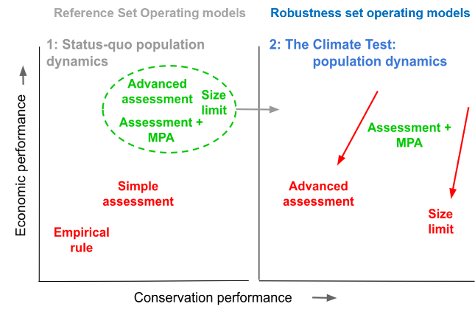

Figure 1. Example of the selection of a climate-ready management procedure using the Climate Test robustness operating models (right) from MPs that performed similarly under the status-quo reference set operating models (left). In this example, the ‘Assessment + MPA’ CMP performed similarly to ‘Advanced assessment’ and ‘Size limit’ CMPs given the reference set (left) but outperformed those given the climate test (right).

Climatological processes

Oceanographic properties affecting habitat

Mechanisms of impact

Operating model dynamics

Figure 2. The components linking climate and population dynamics as represented by the operating model (Tables 1-3). The size of boxes is indicator of the number of process / properties / impacts / types of dynamics identified in the literature review for each of the components.

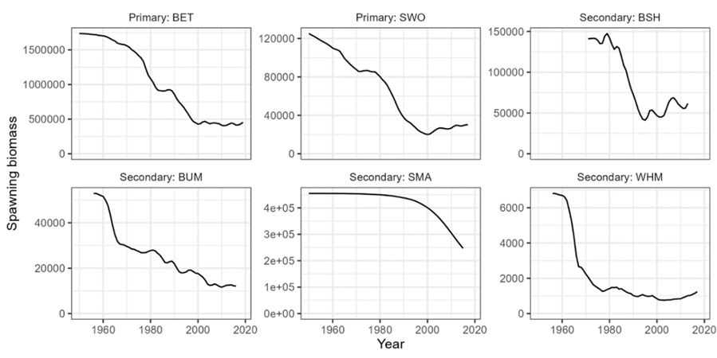

Figure 3. The maximum likelihood estimates of spawning biomass (kg) for the two primary and four secondary species caught in the North Atlantic longline case study (Huynh et al. 2022, Carruthers et al. 2024).

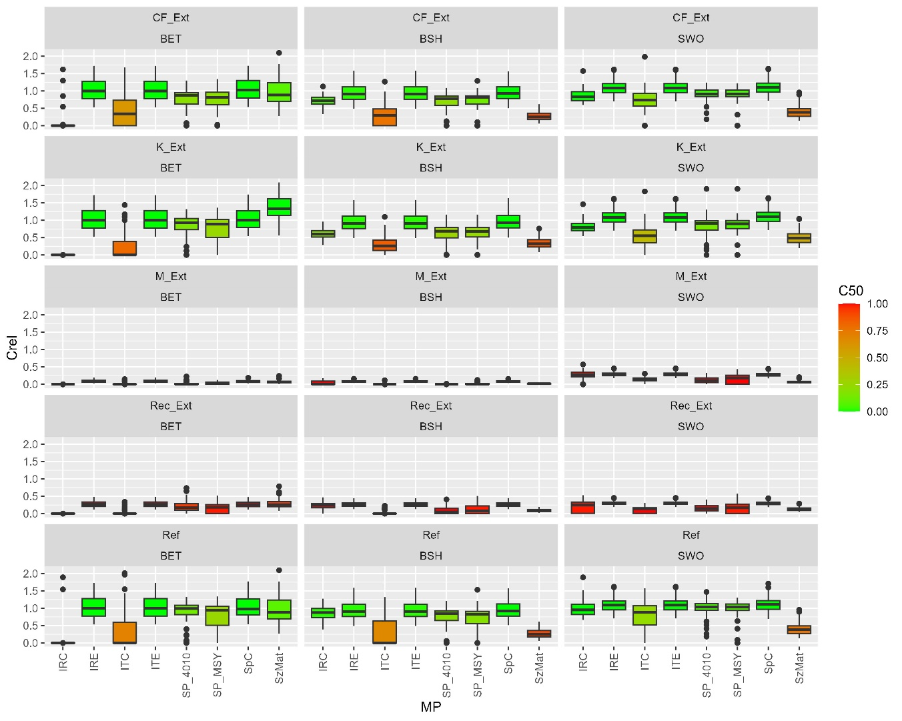

Figure 4. Catch performance after projected years under the extreme climate test scenarios. Catch is measured as the catch in projection year 50 relative to the last historical year. Boxes are colour according to the probability that catch in projection year 50 is below 50% of the last historical year *C50*, where *C50* = P(*Crel* < 0.5).

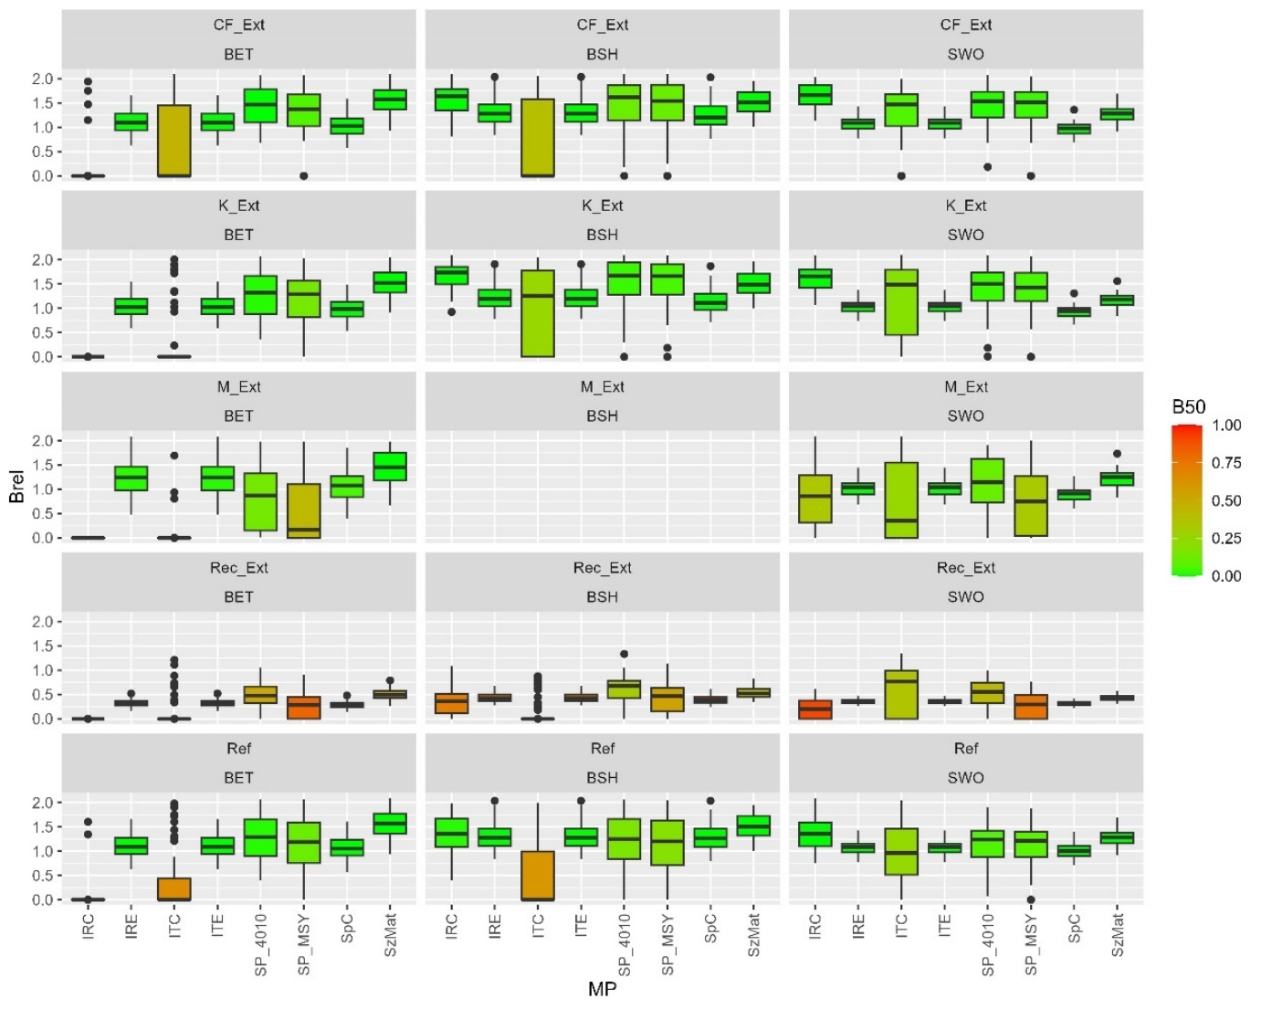

Figure 5. Biomass performance after projected years under the extreme climate test scenarios. Biomass is measured as the spawning stock biomass in projection year 50 relative to equilibrium spawning biomass at MSY (*Brel*). Boxes are coloured according to the probability that spawning biomass in projection year 50 is below 50% of SSBMSY (*B50*), where *B50* = P(*Brel* < 0.5).

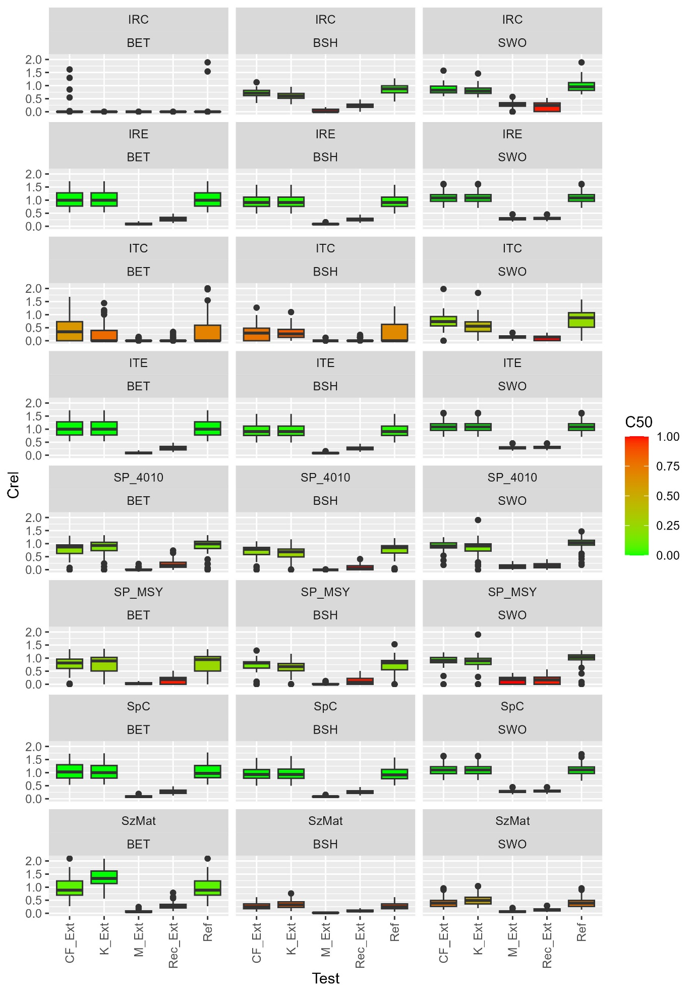

Figure 6. The same catch performance results data as Figure 4 but rearranged for comparison among climate tests (x axis).

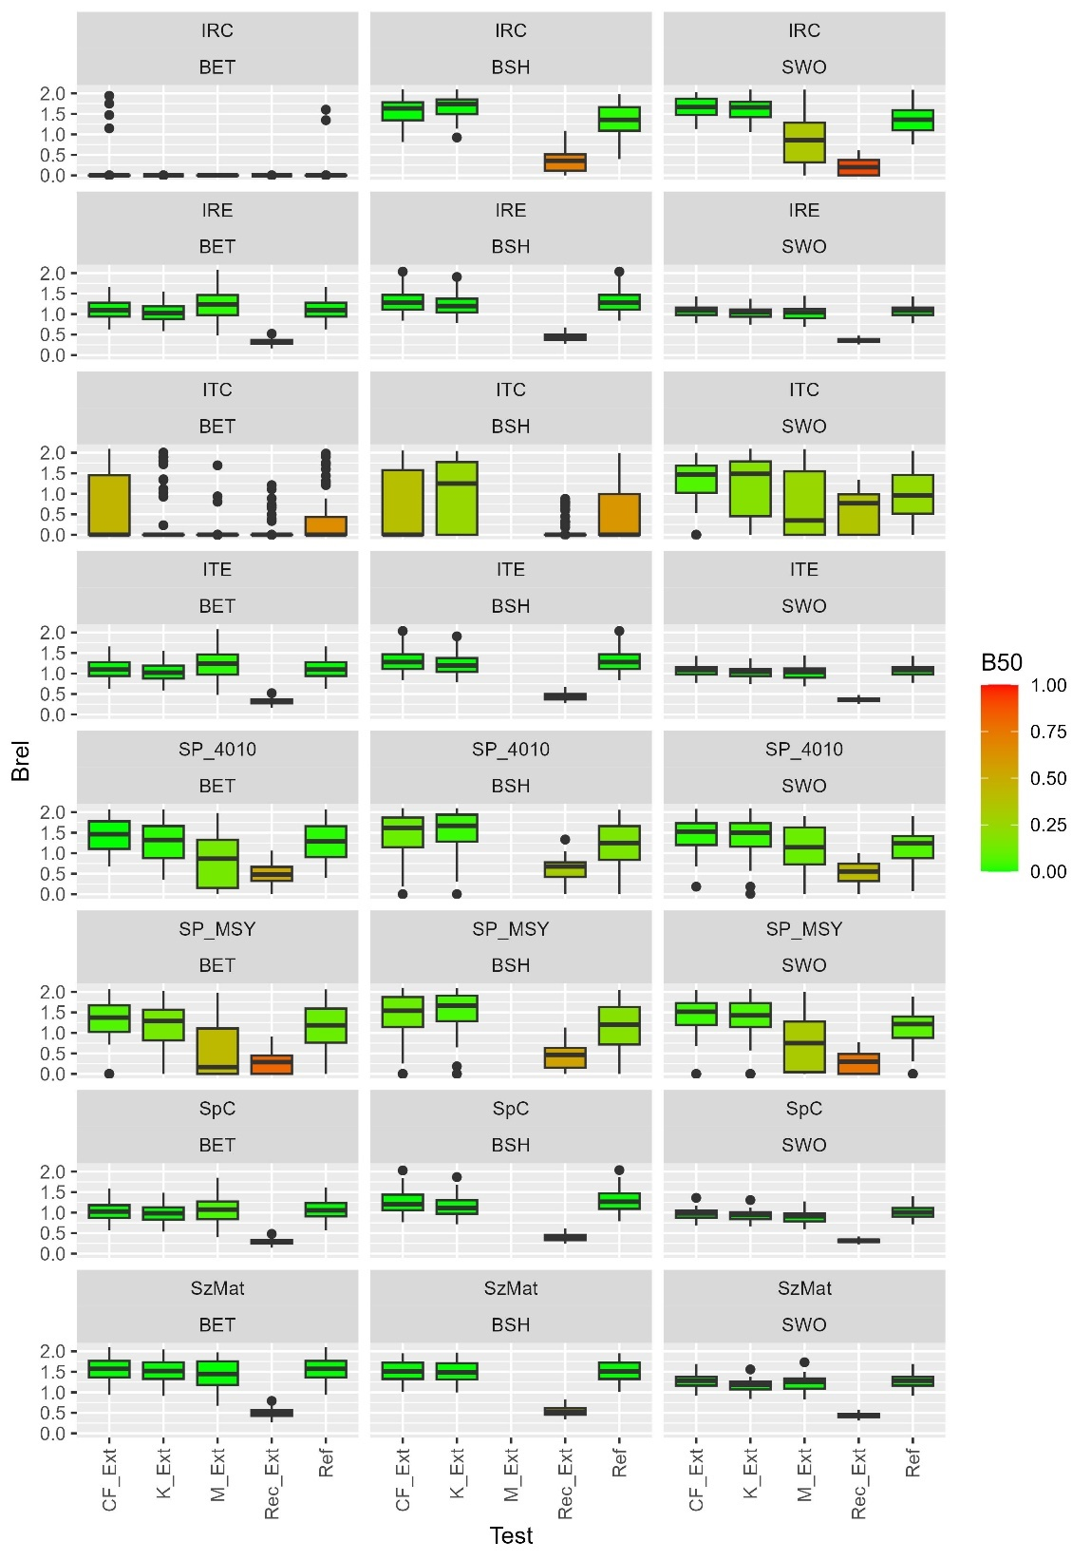

Figure 7. The same biomass performance results data as Figure 5 but rearranged for comparison among climate tests (x axis).

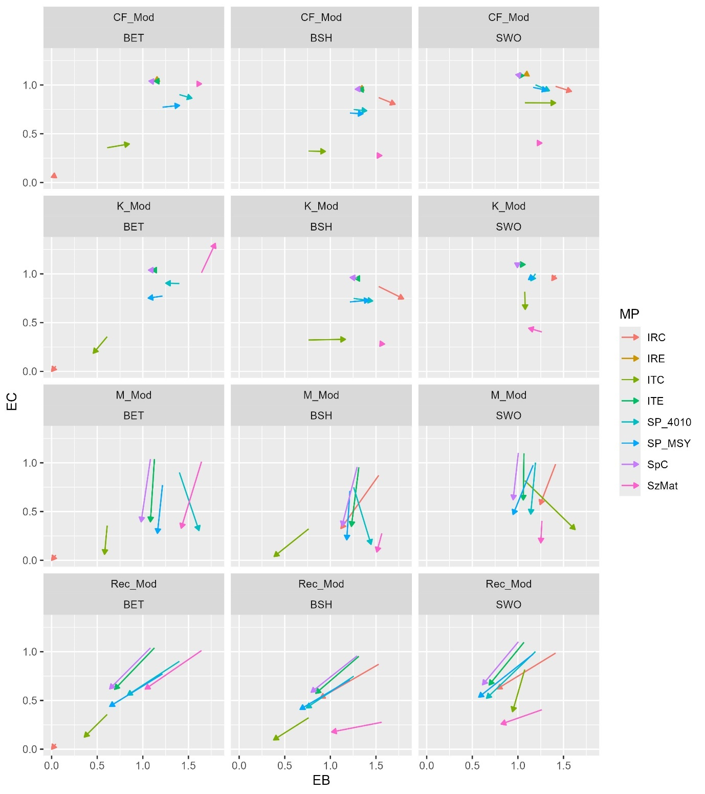

Figure 8. The biomass – yield trade-off for each management procedure for the reference (no climate test, start of arrow) and moderate climate test scenarios. Yield (y axis) is expressed as expected catch (EC): the mean catch in projection year 50 relative to the catch in the last historical. Biomass (x axis) is expressed as expected spawning biomass (EB): the mean spawning biomass in projection year 50 relative to equilibrium spawning biomass at MSY.

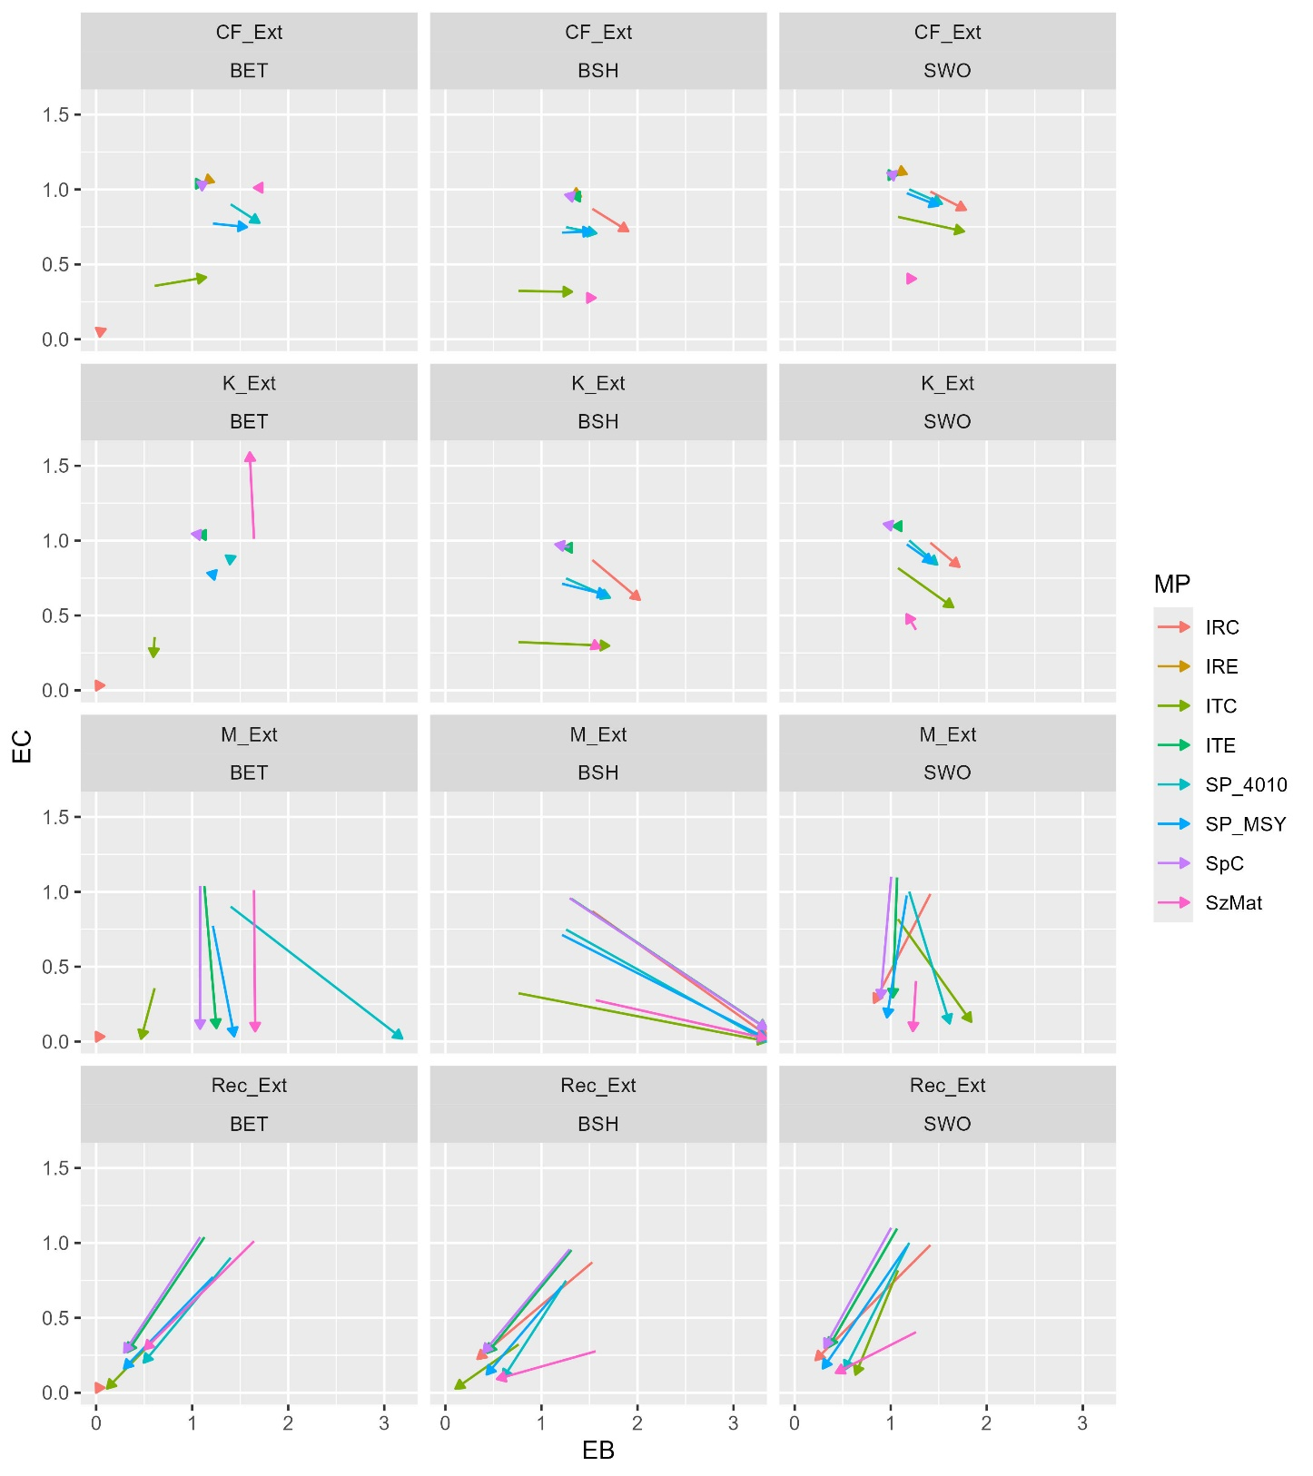

Figure 9. As figure 8 but for the extreme climate test scenarios. Note that the results for blue shark (BSH), M_Ext (extreme natural mortality rate scenario) should be disregarded: there were insufficient simulations with positive biomass to calculate biomass performance statistics reliably.

**Tables**

Table 1. Potential links between climatological process and oceanographic properties impacting habitats of marine pelagic fishes.

|  |  |
| --- | --- |
| **Climatological process** | **Oceanographic properties affecting habitat** |
| Thermal regime | Currents / mixing / stratification (Cai et al. 2005, Wu et al. 2012, Li et al. 2015)  Dissolved oxygen concentration (Stendardo and Gruber 2012)  Macronutrients (Dickson et al. 1996)  Water temperature (Sarmiento et al. 2004, Brickman et al. 2018, Loder and Wang 2015)  pH (Feely et al. 2009) |
| Atmospheric CO2 | Dissolved oxygen concentration  pH (Ganachaud et al. 2011, Caldeira & Wickett 2003) |
| Atmospheric circulation / aeolian inputs | Micronutrients  Currents / mixing / stratification (Sydeman et al. 2014) |
| Riverine inputs | pH (Cai et al. 2011) |
| Ice melt | pH (Comiso et al. 2008)  Currents / mixing / stratification |

Table 2.  Theoretical linkages between oceanographic properties and ecological / biological / behavioral mechanisms that affect pelagic fish species population dynamics, and the operating model dynamics that may be affected.

|  |  |  |
| --- | --- | --- |
| **Oceanographic properties affecting habitat** | **Mechanism** | **Relevant operating model dynamics** |
| Currents / mixing / stratification | Larval dispersal | Recruitment strength |
| Prey availability (Beaugrand and Kirby 2010) | Somatic growth (Perry et al. 2005) |
| Vulnerability to fishing gear | Catchability |
| Water temperature | Physiological stress - thermotaxis | Spatial distribution & phenology (Edwards and Richardson 2004, Perry et al. 2005, Nye et al. 2009, Last et al. 2011, Bell et al. 2011, Erauskin-Extramiana et al. 2019,2020, Tanaka et al. 2021)  Depth distribution (Dulvy et al. 2008, Pinksy et al. 2013)  Catchability (Lehodey et al. 2011, Podestá et al. 1993) |
| Metabolism | Somatic growth  Condition factor  Fecundity |
| Larval survival (Zymaroieva et al. 2024, Lehodey et al. 2011) | Recruitment strength (Beaugrand et al. 2003, Beaugrand 2009, Ling et al. 2008)  Variability in recruitment  Carrying capacity (Thomas et al. 2004, Thomas 2010), |
| Prey availability (Karnasuskas et al. 2015, Beaugrand and Kirby 2010) | Somatic growth  Natural mortality  Condition factor  Fecundity |
| Thermal stress (acute, chronic) (Lehodey et al. 2011, immunosuppression | Somatic growth (O’Connor et al. 2014)  Natural mortality (Pereira Campos et al. 2023)  Condition factor  Fecundity  Range contraction / expansion (MacLeod 2009) |
| Foraging (Karnasuskas et al. 2015) | Somatic growth (Pistevos et al. 2015)  Natural mortality  Condition factor  Fecundity (Bell et al. 2011) |
| Spawn timing (Fincham et al. 2013) | Recruitment strength |
| Dissolved oxygen concentration | Metabolism | Spatial distribution (Stramma et al. 2012, Hazen et al. 2013)  Somatic growth (Pollock et al. 2007, Pörtner and Knust 2007, Stramma et al. 2010, 2012, Gilly et al 2013)  Condition factor  Fecundity  Post release mortality (Dell’Apa et al. 2023) |
| Macronutrients | Prey availability | Somatic growth  Condition factor |
| Micronutrients | Primary productivity | Juvenile survival |
| Salinity | Physiological stress | Larval survival |
| pH | Physiological stress | Spatial distribution  Behavior  Larval survival |

Table 3. Demonstration climate tests for single-species operating models. Percentages are cumulative linear changes over 50 projected years. Direction of changes follows the qualitative consensus of various papers (Table 2)

|  |  |  |  |
| --- | --- | --- | --- |
| **Operating model dynamics** | **Scenario** | **Moderate** | **Extreme** |
| Somatic growth | von Bertalanffy growth rate *K*  Declines (Dell’Apa et al. 2023) | -20%  ‘K_Mod’ | -40%  ‘K_Ext’ |
| Mean recruitment strength  (juvenile survival, carrying capacity) | Mean recruitment  Declines | -25%  ‘Rec_Mod’ | -50%  ‘Rec_Ext’ |
| Survival  (juvenile and adult). | Instantaneous natural mortality rate M  Declines | 25%  ‘M_Mod’ | 50%  ‘M_Ext’ |
| Condition factor | Weight-at-length  Declines | -10%  ‘CF_Mod’ | -20%  ‘CF_Ext’ |
| Reference run | No change in operating model dynamics. | ‘Ref’ | |

Table 4. Documented stock assessments (Stock Synthesis 3)  used as the basis for constructing preliminary multi-stock, multi-fleet operating models for the North Atlantic longline case study (Huynh et al. 2022, Carruthers et al. 2024).

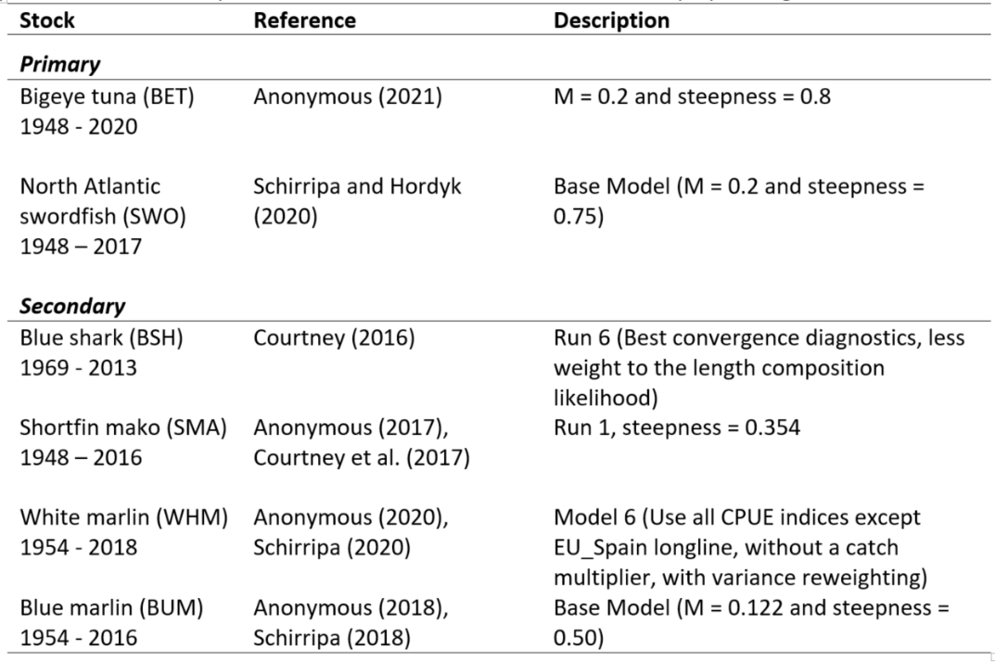

Table 5. Management procedures tested

|  |  |
| --- | --- |
| **Code** | **Description** |
| SzMat | Size Limit at Maturity: Perfectly-enforced size limit at the length that 50% of individuals mature |
| ITC | Index Target Catch: an MP that makes incremental (up to 10% changes) to total allowable catch (TAC) to reach an index level at BMSY. The index data are simulated with observation error (20% CV), but the true target index level at SSBMSY is known. |
| ITE | Index Target Effort: as ITC but makes incremental changes to the total allowable effort (TAE). |
| IRC | Index Ratio Catch: an MP that aims to fish at a constant (UMSY) rate of fishing. TAC changes are up to a 10%. The index data are simulated with observation error (20% CV) but the true ratio of UMSY to the index level at SSBMSY is known. |
| IRE | Index Ratio Effort: as IRC but adjusting TAE. The index data are simulated with observation error (20% CV) but the true ratio of UMSY to effort *E*, is known. Catchability *q*, (*F* = *qE*) changes have an annual CV in the range of [10%, 20%] and an annual percentage change in the range of [-0.5%, 0.5%]. |
| SP_MSY | Surplus production – MSY: A state-space surplus production stock assessment model is fitted to simulated catch and index data and provides TAC advice that is current estimated vulnerable biomass multiplied by estimated UMSY. |
| SP_4010 | Surplus production – 40:10 harvest control rule: As SP_MSY but includes a ‘40:10’ harvest control rule where zero exploitation rate is recommended when estimated SSB is below 10% SSB0, exploitation rate is linearly ramped to UMSY levels beween 10% and 40% SSB0, and UMSY exploitation rate is recommended for when current SSB is estimated to be above 40% SSB0. |
| SpC | Spatial closure: effort (but can be redistributed) is restricted for half of the available habitat. When index levels are above SSBMSY levels all habitat is open to fishing. As index levels decline below SSBMSY levels, there is a linear decline in access to half of the habitat. The index data are simulated with observation error (20% CV), but the true target index level at SSBMSY is known. Operating models have full spatial mixing. |

Table 6. An illustrative example of asymmetric performance outcomes for an evaluation of the current management approach (Current MP) and that of a newly designed ‘climate-ready’ MP (Climate MP) for

|  |  |  |  |  |  |  |  |
| --- | --- | --- | --- | --- | --- | --- | --- |
| *Relative management performance (larger is better)* | | Example A | |  |  | Example B | |
| Reference set | Climate test |  |  | Reference set | Climate test |
| MP | Current MP | 100% | 75% |  | Current MP | 100% | 90% |
| Climate MP | 95% | 100% |  | Climate MP | 50% | 100% |

1. Blue Matter Science Ltd. 2150 Bridgman Ave, N. Vancouver. V7P 2T9.